**Ideation Phase**

**Health AI:Intelligent Healthcare Assistant Using IBM Granite**

**Template**

| Date | 30 June 2025 |
| --- | --- |
| Team ID | LTVIP2025TMID60828 |
| Project Name | HealthAI: Intelligent Healthcare Assistant Using IBM Granite |
| Maximum Marks | 4 Marks |

### HealthAI: Intelligent Healthcare Assistant Using IBM Granite

## Project Description:

HealthAI harnesses IBM Watson Machine Learning and Generative AI to provide intelligent healthcare assistance, offering users accurate medical insights. The platform includes a Patient Chat for answering health-related questions, Disease Prediction that evaluates user-reported symptoms to deliver potential condition details, Treatment Plans that provide personalized medical recommendations, and Health Analytics to visualize and monitor patient health metrics.

Utilizing IBM's Granite-13b-instruct-v2 model, HealthAI processes user inputs to deliver personalized and data-driven medical guidance, improving accessibility to healthcare information. Built with Streamlit and powered by IBM Watson, the platform ensures a seamless and user-friendly experience. With secure API key management and responsible data handling, HealthAI empowers users to make informed health decisions with confidence.

Scenarios:

Scenario 1: A user inputs their symptoms into the Disease Prediction system, describing issues like persistent headache, fatigue, and mild fever. The system analyzes the symptoms along with the patient's profile and health data to provide potential condition predictions, including likelihood assessments and recommended next steps.

Scenario 2: A user needs personalized treatment recommendations for a diagnosed condition. By entering their condition in the Treatment Plans generator, the AI processes the information along with patient data to create a comprehensive, evidence-based treatment plan that includes medications, lifestyle modifications, and follow-up testing.

Scenario 3: A user wants insights about their health trends. Using the Health Analytics dashboard, they can visualize their vital signs over time (heart rate, blood pressure, blood glucose, etc.) and receive AI-generated insights about potential health concerns and improvement recommendations.

Scenario 4: A user has a health-related question. Through the Patient Chat

Reference: <https://www.mural.co/templates/brainstorm-and-idea-prioritization>

**Step-1: Team Technical Architecture:**

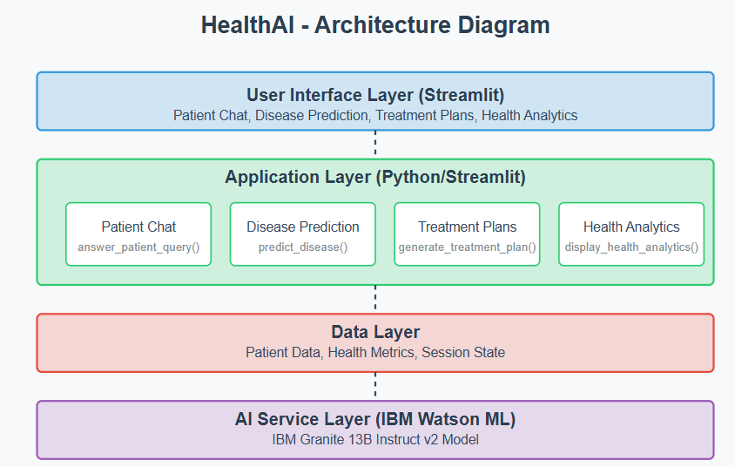

### project workflow

#### Activity 1: Model Selection and Architecture

* Activity 1.1: Research and select the appropriate AI model from IBM Watson for medical assistance (IBM Granite 13B Instruct v2).
* Activity 1.2: Define the architecture of the application, detailing interactions between the frontend, backend, and AI integration.
* Activity 1.3: Set up the development environment, installing necessary libraries and dependencies for Streamlit and IBM Watson ML.

#### Activity 2: Core Functionalities Development

* Activity 2.1: Develop the core functionalities: Patient Chat, Disease Prediction, Treatment Plan Generation, and Health Analytics.
* Activity 2.2: Implement patient data utilities to manage and visualize health metrics.  
    
    
  Activity 3: App.py Development
* Activity 3.1: Write the main application logic in app.py, establishing functions for each feature and integrating AI responses.
* Activity 3.2: Create prompting strategies for the IBM Granite model to generate high-quality medical content.

#### Activity 4: Frontend Development

* Activity 4.1: Design and develop the user interface using Streamlit components, ensuring a responsive and intuitive layout.
* Activity 4.2: Create dynamic visualizations with Plotly to display health metrics and trends.

#### Activity 5: Deployment

* Activity 5.1: Prepare the application for deployment by configuring environment variables for API credentials.
* Activity 5.2: Deploy the application on a suitable hosting platform to make it accessible to users.

Milestone 1: Model Selection and Architecture

In this milestone, we focus on selecting the appropriate AI model from IBM Watson for our medical assistance needs. This involves researching the capabilities and performance of various models, ensuring that the chosen model aligns well with our application's objectives of creating a Patient Chat system, Disease Prediction, Treatment Plan Generation, and Health Analytics.

**Milestone 2: Core Functionalities Development**

**This Milestone contains about Core Functionalities Development.**

**Step-3:**